Opening a Sushi Bar

Fabio Antonini

04/23/20

Introduction

Background
In recent years there has been the multiplication of a new type of fast food restaurants based on fish: the sushi bar. Conquered by the wholesomeness of the ingredients and their freshness, by the delicate flavors and by the thousand variables of tastes and combinations, the Italians, and not only, have been conquered by Japanese cuisine and especially by sushi. Hence the proliferation of places specializing in sushi such as sushi kiosks, sushi bars and gourmet restaurants of Japanese cuisine, which, from a simple trend, have now become an integral part of Italian food.
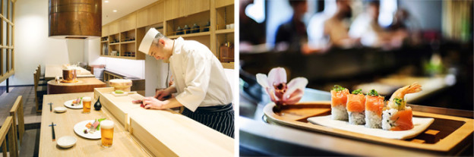
Opening a sushi restaurant, given its great success, is still possible with excellent results despite the high competition and, precisely because of this, it is essential to study a format and a proposal that combines the tradition of Japanese cuisine with innovation . An interesting idea is certainly to open a sushi bar, or a more informal place where customers, seated at tables or at a counter, can enjoy fresh sushi prepared in front of their eyes by a competent sushi man.

How to be successful
Even if the target audience is expanding, it is good to remember that the main clientele of a sushi bar, at least in Italy, is mainly composed of young people between 20 and 40 years old. On the basis of this main target, pricing, promotion and communication strategies will therefore have to be calibrated, as well as the design and preparation of spaces and environments.
An accurate choice of location will be essential to open a successful sushi bar. A small to medium-sized commercial space (50 to 70 m2 based on the number of seats will suffice) located in large cities (catchment area of about 30,000 inhabitants or more) where there is a target consisting mainly of young people, tourists, students and young workers who love news and fun will be the ideal place for the opening of a successful sushi bar.
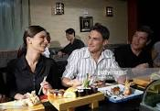

To open a small sushi bar you will need a minimum investment of approximately 50,000 euros.

My goal
An old aunt left a nice nest egg to the undersigned: 1 million euros. I can finally realize my dream: to open a trendy restaurant in one of the most beautiful Italian cities.
I have always worked in the world of catering and I am doing well in the kitchen. To follow my dreams I went to Japan and spent 5 wonderful years learning the secrets of Sushi.

Also I love being among young people. So my dream is to open a Sushi Bar in a university city where there are many young people. The choice falls on Bologna, a city full of young people with a historical university.
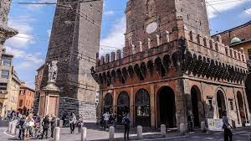
The opening price may be lower than in other cities. There would be competition in any case because Bologna is full of clubs. There are not as many foreign tourists as in Rome or Milan, so opening in Bologna would have this penalty. But the city is sensitive to news and this is a plus. Since I am convinced of my skills and the fact that my Sushi bar can offer something better than the competition, I will try to rent the place where there is a greater concentration of restaurants and possibly Sushi Bars. Obviously I will try to stay as close as possible to the center, compatibly with the cost of the rent. I will try to identify areas with the biggest concentration of young people.

Interest
This study will help anyone who wants to start a restaurant business in a young and dynamic city like Bologna The business plan that will be illustrated has a general value: anyone who wants to open a restaurant somewhere will find the illustrated methodology and the examples provided useful. The considerations made can be applied to any city and to any type of restaurant / pub / caffee shop etc etc.

Data
The following data sources will be needed to extract/generate the required information:

- A Pandas dataframe will be provided with some data about the main Bologna's neighborhoods (name, area, density of inhabitants, sub-districts)
- The dataframe will be enriched by the cohordinates (latitude and longitudes) of candidate areas that will be generated algorithmically and approximate addresses of centers of those areas will be obtained using Google Maps API reverse geocoding.
- Number of restaurants and their type and location in every neighborhood will be obtained using Foursquare API.
- The list of Sushi Bars in the Bologna neighborhoods and their location with respect to the center of the selected neighborhood will be retrieved using Foursquare API.
- For each Sushi Bar I will analyze the number of clicks received and the comments. From these data I will be able to understand the age of the clientele in relation the position of the restaurant itself.

Data acquisition and cleaning
The information of the Bologna districts was read from the wikipedia page available at
https://it.wikipedia.org/wiki/Quartieri_di_Bologna.
The data read was rather 'dirty' and therefore it was necessary to perform a 'cleaning' of the dataframe. In the end the result was illustrated in the following table.
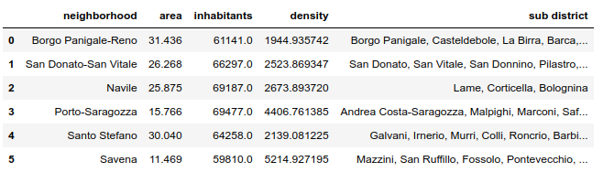
The population density is swown in the following picture.
The neighborhoods with the maximum and minimum population density were highlighted. The highest one is Savena.The lowest one is Borgo Panigale.

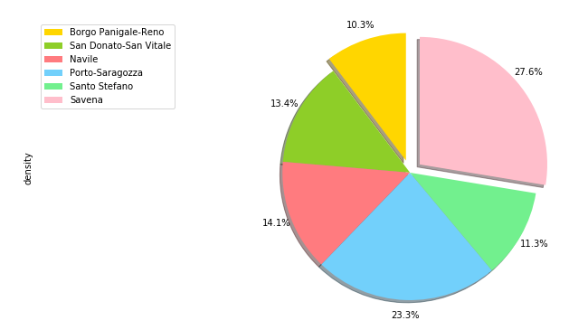
The geograpical coordinate of Bologna are 44.4936714, 11.3430347. Here below the Bologna’s map obtained by Folium. Some popup showing the population density have been added to the map.

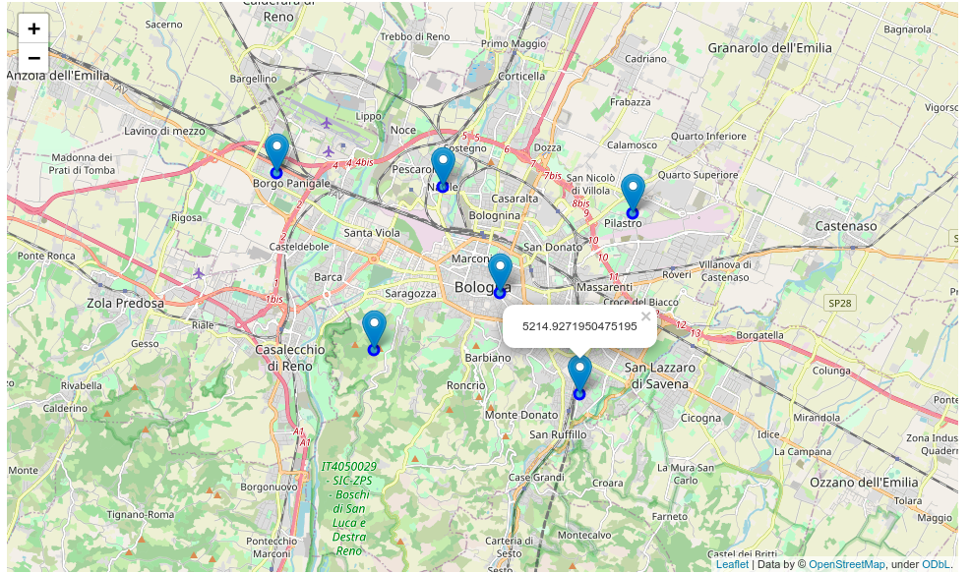
Now we want to create a `Choropleth` map of Bologna. We will use the choropleth method with the following main parameters:

1. geo_data, which is the GeoJSON file.
2. data, which is the dataframe containing the data.
3. columns, which represents the columns in the dataframe that will be used to create the `Choropleth` map.
4. key_on, which is the key or variable in the GeoJSON file that contains the name of the variable of interest. To determine that, you will need to open the GeoJSON file using any text editor and note the name of the key or variable that contains the name of the neighborhoods, since the neighborhoods are our variable of interest. In this case, **name** is the key in the GeoJSON file that contains the name of the neighborhoods. Note that this key is case_sensitive, so you need to pass exactly as it exists in the GeoJSON file.

Unfortunately the ‘geojson’ file wasn’t available from the web for the Bologna city area. So I had to built by myself using the helpful website geojson.io.
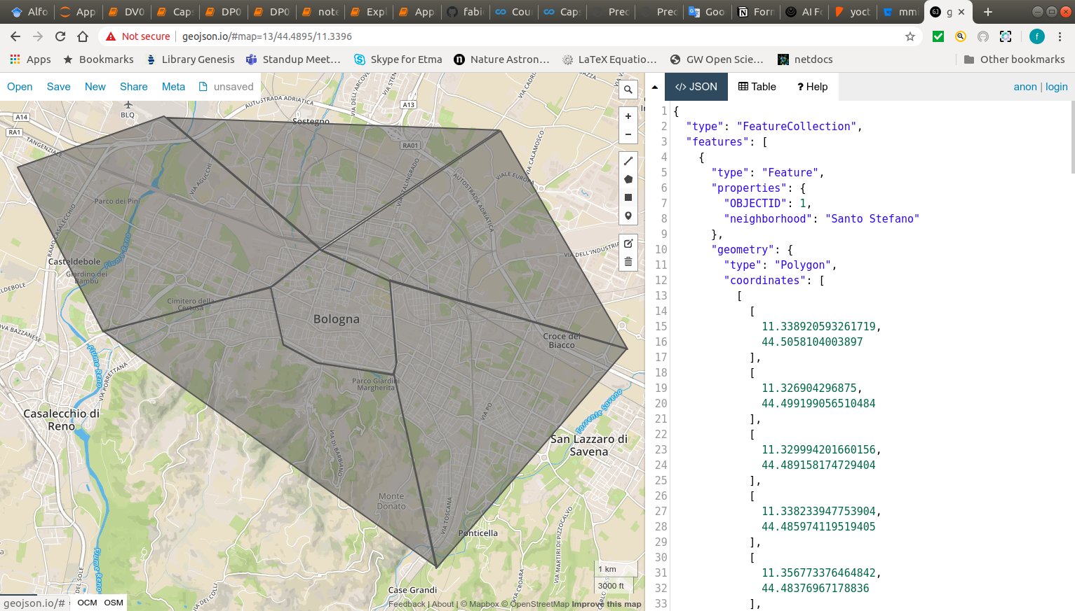
So we have been able to display a choropleth of the Bologna area.
